Infosys Internship Learning Summary (Day-wise)
Day 1 – 10/11/25
- Introduction: Overview of internship workflow, expectations, and guidelines.
- Project Allocation: Assigned the Smart Stock Inventory Optimisation project and responsibilities.

Day 2 – 11/11/25
- Tech Stack Selection: Decided on tools like Python, Fast API/Flask, Django, ML models, and databases.
- API Basics: Understood how APIs allow communication between client and server.
- Postman: Learned to test and debug APIs using requests and responses.
- WebSocket: Understood real-time data exchange through persistent server connection.
- NumPy: NumPy is a Python library used for fast numerical operations on large arrays and matrices.
- Pandas: Pandas is a Python library that helps you handle, clean, and analyze data using DataFrames.

Day 3 – 12/11/25
- Fast API: High-performance Python framework for building fast, modern APIs.
- Flask API: Lightweight Python framework used for simple and flexible API development.
- Pydantic: Library for validating and converting data using Python models.

Day 4 – 13/11/25
- GitHub: Platform for code storage, version control, and team collaboration.
- git init
Creates a new Git repository in your project folder.
- git clone <url>
Copies an existing remote repository to your system.
- git status
Shows changes in your working directory.
- git add .
Stages all changed files for the next commit.
- git add <filename>
Stages a specific file.
- git commit -m "message"
Saves your staged changes with a message.
- git push origin main
Uploads your commits to the main branch on GitHub.
- git pull
Downloads and merges the latest changes from the remote repository.
- git branch
Shows all branches in your repository.
- git branch <name>
Creates a new branch.
- git checkout <branch>
Switches to another branch.
- git merge <branch>
Combines another branch into the current branch.
- git log
Shows commit history.
- git remote -v
Shows linked remote repositories.
- Virtual Environment: Isolated Python environment to manage project-specific packages.
- requirements.txt: File listing all dependencies needed to run the project.

Day 5 – 14/11/25
- Payload: The actual data sent in an API request or response.
- Endpoint: A specific API URL that performs a defined action.
- AI Models: Algorithms that learn patterns from data to make predictions or decisions.
- Types of Machine Learning: Supervised, unsupervised, and reinforcement learning approaches.
- Llama Model: A large language model useful for NLP and text-generation tasks.

Day 6 – 16/11/25
- Database Concepts: Learned tables, keys, relationships, and data storage principles.
- Normalisation: Process of organising data to reduce redundancy and improve consistency.
- 1NF – First Normal Form: Data is organized so each column has atomic values and no repeating groups.
- 2NF – Second Normal Form: The table is in 1NF and every non-key column depends on the whole primary key.
- 3NF – Third Normal Form: Table is in 2NF and has no transitive dependencies (non-key fields don't depend on other non-key fields).
- BCNF – Boyce Codd Normal Form: Stronger version of 3NF where every determinant must be a candidate key.
- 4NF – Fourth Normal Form: Table must not contain multivalued dependencies.
- 5NF – Fifth Normal Form: Data is broken into tables to avoid join dependency issues.
- PostgreSQL vs MySQL: PostgreSQL is feature-rich and strict, and MySQL is simpler and faster for basic use.
- Vector Databases: Databases that store embeddings for AI search, similarity, and recommendations.

Day 7 – 17/11/25
- GitHub Repository: A centralised place to store and manage version-controlled project code.
- Project Review: Evaluated current project progress and clarified next development steps.

Day 8– 18/11/25
1. Tokenization
This breaks a sentence into smaller pieces called tokens.
Example:
“Machine learning is fun”
→ ["Machine", "learning", "is", "fun"]

2. Stop Word Removal
Common words like "is", "the", "and" are removed because they don’t add much meaning.
Example:
["Machine", "learning", "is", "fun"]
→ ["Machine", "learning", "fun"]

3. Stemming
Cuts words to their root form. It may not always give a proper dictionary word.
Example:
“running”, “runner”, “runs” → “run”

4. Lemmatization
Converts words to their meaningful base form using grammar rules.
Example:
“better” → “good”
“studies” → “study”

5. POS Tagging (Part of Speech)
Labels each word with its grammatical role.
Example:
“The smart student solved the problem”
→ [("smart", JJ), ("student", NN), ("solved", VBD)]

6. Named Entity Recognition (NER)
Identifies important real-world names.
Example:
“Elon Musk founded SpaceX in 2002”
→ Elon Musk (PERSON), SpaceX (ORG), 2002 (DATE)

7. Bag of Words (BoW)
Represents text using basic word counts.
Example texts:
- “I love Python”
- “I love coding”
Vocabulary: ["I", "love", "Python", "coding"]
Vectors:
1 → [1, 1, 1, 0]
2 → [1, 1, 0, 1]

8. TF-IDF
Gives weight to words that are important in a document but rare in others.
This helps highlight meaningful words.
Example:
In 10 documents, if “data” appears in 1 document:
IDF = log(10/1) = log(10)
→ high importance

9. Logistic Regression
A classification algorithm that predicts probabilities using the sigmoid function.
Sigmoid Formula:
[
sigma(z) = frac{1}{1 + e^{-z}}
]
Output is between 0 and 1.
If probability ≥ 0.5 → class 1
Else → class 0
Used for: spam detection, pass/fail prediction, sentiment analysis.

10. SVM (Support Vector Machine)
A powerful classifier that tries to find the best boundary between classes.
Great for text classification when combined with TF-IDF.
Example:
Train SVM on positive and negative sentences.
Input: “This product is amazing”
Output: positive

01/12/25
1. Margin (in ML)
Margin refers to the distance between the decision boundary and the closest data points of any class.
- A large margin means the model separates classes confidently.
- A small margin means the classes sit closer to the boundary and the model is less confident.
Example:
Imagine drawing a line to separate cats and dogs in a 2D graph. Margin is how far the nearest cat or dog is from that line.
Formula idea (SVM style):
Margin = ( \frac{2}{||w||} )
Where ( w ) is the weight vector of the separating hyperplane.

2. Hard Margin (SVM)
Hard margin means you force the model to perfectly separate all data points with no misclassification.
When used:
Only when data is perfectly linearly separable.
Example:
Points of two classes lie perfectly on opposite sides of a line.
Any point crossing the boundary is not allowed.
Limitation:
Real-world data is noisy and rarely separable, so hard margin is risky.

3. Soft Margin (SVM)
Soft margin allows some misclassification to get a better overall model. It balances accuracy and generalization.
When used:
For real-world messy data.
Hyperparameter:
C (penalty parameter)
- High C → less tolerance for misclassification
- Low C → more tolerance, smoother boundary
Example:
If two or three cat points fall slightly in the dog region, the model still tries to separate with minimal overall error.

4. Reinforcement Learning (RL)
RL is a learning approach where an agent learns by interacting with an environment and receiving rewards or penalties.
Core idea:
Try → observe result → adjust action → repeat.
Formula (Q-learning update):
[
Q(s, a) = Q(s, a) + \alpha (r + \gamma \max_{a'} Q(s', a') - Q(s, a))
]
Where:
- ( s ) = current state
- ( a ) = current action
- ( r ) = reward
- ( s' ) = next state
- ( \alpha ) = learning rate
- ( \gamma ) = discount factor
Example:
A robot learns to walk by getting +1 for moving forward and -1 for falling.

5. Human-in-the-Loop (HITL)
This means the model learns with human supervision during training, evaluation, or feedback.
Example:
A chatbot suggests replies, but a human edits them.
The model learns from those corrections.

6. Without Human Interaction
Here the system learns only from its own experience (pure RL) or uses auto-generated feedback.
Example:
A self-driving car simulator learns by running millions of virtual drive attempts without humans involved.

7. Agentic AI
Agentic AI systems can plan, act, evaluate results, and improve themselves across multiple steps.
They don’t just answer questions; they perform tasks.
Example:
An AI that:
- Reads your emails
- Extracts tasks
- Creates a schedule
- Books meetings automatically
- Learns from your feedback
It behaves like an autonomous “agent.”

8. Auto-gen or Autonomous Generation
This refers to AI systems that generate content, code, or actions automatically across multiple loops without human guidance.
Example:
An AI writing code, testing it, debugging it, and improving it by itself.

Day 10 – 20/11/25
1. Logistic Regression
Use: Binary classification (yes/no, buy/not buy)
Formula:
p = 1 / (1 + e^(- (wᵀx)))
Python:
from sklearn.linear_model import LogisticRegression

2. Decision Tree
Use: Simple if-else based classification or regression.
Key Idea: Splits data using metrics like Gini or Entropy.
Entropy Formula:
Entropy = - Σ p_i log2(p_i)
Gini Formula:
Gini = 1 - Σ p_i²
Python:
from sklearn.tree import DecisionTreeClassifier, DecisionTreeRegressor

3. Random Forest
Use: Many decision trees combined for better accuracy.
Key Idea:
Prediction = Majority vote (classification)
Prediction = Average of all trees (regression)
Python:
from sklearn.ensemble import RandomForestClassifier, RandomForestRegressor

4. KNN (K-Nearest Neighbors)
Use: Classification and regression based on nearest neighbors.
Distance Formula (Euclidean):
d = √ Σ (x_i - y_i)²
Python:
from sklearn.neighbors import KNeighborsClassifier, KNeighborsRegressor

5. K-Means Clustering
Use: Grouping items or customers based on similarity.
Centroid Distance Formula:
d = √ Σ (x_i - μ_i)²
Centroid Update:
μ = Average of all points in the cluster
Python:
from sklearn.cluster import KMeans

6. XGBoost
Use: High-accuracy prediction for inventory optimization.
Model Idea:
XGBoost builds many boosted decision trees that reduce error step-by-step.
Loss Function (simplified):
Obj = Σ (prediction - actual)² + regularization
Python:
import xgboost as xgb
from xgboost import XGBRegressor, XGBClassifier

7. Overfitting vs Underfitting
Overfitting
Model learns too much noise.
High training accuracy, low test accuracy.
Underfitting
Model is too simple.
Low accuracy on both training and test.
Fix Overfitting
- Reduce tree depth
- Increase regularization
- Add dropout (for neural nets)
Fix Underfitting
- Add more features
- Increase model complexity
- Increase epochs (for DL)

02/12/25
1. SQL Basics
SQL is used to work with databases. You can store, update, delete, and fetch data using different commands.
Main Commands
- SELECT – fetch data
- INSERT – add new records
- UPDATE – change existing data
- DELETE – remove data
- CREATE – create tables or databases
- ALTER – change table structure
- DROP – delete a table or database
- TRUNCATE – delete all rows quickly

2. WHERE Clause
Used to filter specific rows.
Example:
SELECT * FROM Employees
WHERE country = 'India';
You can also use:
- AND
- OR
- NOT
Example:
SELECT * FROM Employees
WHERE country = 'India' AND department = 'IT';

3. Operators
Comparison
= , > , < , >= , <= , != , <> , BETWEEN, LIKE, IN, NOT IN
Example:
SELECT * FROM Products
WHERE price BETWEEN 100 AND 500;

4. LIKE Operator (Pattern Matching)
Used to find strings with patterns.
Examples:
- a% → starts with a
- %a → ends with a
- %or% → contains "or"
- a_% → a + one character + anything
- a__% → a + two characters + anything
- a%0 → starts with a and ends with 0
Example:
SELECT name FROM Students
WHERE name LIKE 'a%';

5. IN and NOT IN
Used to match one value from a list.
Example:
SELECT * FROM Employees
WHERE country IN ('India', 'USA', 'Japan');
To exclude:
WHERE country NOT IN ('India', 'USA', 'Japan');

6. ORDER BY
Used to sort results.
Example:
SELECT * FROM Employees
ORDER BY salary DESC;

7. Aggregate Functions
Used for calculations on groups of rows.
- COUNT()
- SUM()
- AVG()
- MIN()
- MAX()
Example:
SELECT COUNT(*) FROM Employees;

8. GROUP BY
Groups rows with common values.
Example:
SELECT department, COUNT(*)
FROM Employees
GROUP BY department;
This shows how many people are in each department.

9. HAVING
Filters groups after using GROUP BY.
It works on aggregated results.
Example:
SELECT department, COUNT(*)
FROM Employees
GROUP BY department
HAVING COUNT(*) > 5;

10. Joins
Used to combine data from two tables.
INNER JOIN
Returns matching rows.
LEFT JOIN
Returns all rows from the left table.
RIGHT JOIN
Returns all rows from the right table.
FULL OUTER JOIN
Shows all data from both tables.
Example:
SELECT Students.name, Courses.course_name
FROM Students
INNER JOIN Courses
ON Students.course_id = Courses.course_id;

DATE-03/12/25
1. YOLO Algorithm
YOLO (You Only Look Once) is a single-shot object detection model.
It processes the whole image in one forward pass and predicts:
- Object classes
- Bounding boxes
- Confidence score
The image is divided into an S × S grid, and each grid cell predicts:
- B bounding boxes
- Object confidence
- Class probabilities
This makes YOLO very fast and suitable for real-time use.

5. When to Use YOLO
- Real-time video analytics
- CCTV/Surveillance
- Retail stock detection
- Traffic and road scene detection
- Industrial automation

1. Conversion Functions in Python
Conversion functions are used to change one data type into another.
int()
Converts a number or string into an integer.
int("10") # 10
int(5.9) # 5
float()
Converts data into a decimal number.
float("3.5") # 3.5
float(4) # 4.0
str()
Converts any value into a string.
str(100) # "100"
list()
Converts iterable data into a list.
list("abc") # ['a', 'b', 'c']
tuple()
Converts iterable into a tuple.
tuple([1, 2]) # (1, 2)
set()
Converts iterable into a set and removes duplicates.
set([1, 1, 2]) # {1, 2}
dict()
Converts key-value pairs into a dictionary.
dict([("a", 1), ("b", 2)])
Important point:
Use conversion functions to handle input data correctly.

2. Mathematical Functions
These are built-in functions for calculations.
abs()
Returns positive value.
abs(-10) # 10
sum()
Adds all elements.
sum([1, 2, 3]) # 6
min() and max()
Find smallest and largest values.
min(2, 5, 1) # 1
max(2, 5, 1) # 5
pow()
Raises power.
pow(2, 3) # 8
round()
Rounds numbers.
round(3.456, 2) # 3.46

3. Lambda Function
A lambda is a small one-line function without a name.
square = lambda x: x * x
square(5) # 25
Used with map(), filter().
nums = [1, 2, 3]
list(map(lambda x: x * 2, nums))
Difference from normal function:
- No name
- Single expression only

4. Class and Object Related Functions
- getattr()
Gets attribute value.
getattr(obj, "name")
- setattr()
Sets attribute value.
setattr(obj, "age", 21)
- hasattr()
Checks if attribute exists.
hasattr(obj, "age") # True or False
- delattr()
Deletes attribute.
delattr(obj, "age")
- isinstance()
Checks object type.
isinstance(10, int) # True
- issubclass()
Checks inheritance.
issubclass(B, A)

5. Attributes and Parameters
Attributes
Variables that belong to an object.
self.name
Parameters
Variables in function definition.
def greet(name):
Simple difference:
- Attributes store object data
- Parameters receive input

6. try, except, finally
Used for error handling.
try:
x = 10 / 0
except ZeroDivisionError:
print("Error")
finally:
print("Always runs")
Meaning:
- try → risky code
- except → handle error
- finally → cleanup code

7. Memory and Object Management
del()
Deletes variable reference.
del x
gc.collect()
Forces garbage collection.
import gc
gc.collect()
Important:
- del removes reference
- GC removes unused objects

8. Working with Iterables
iter()
Creates iterator.
nums = [1, 2, 3]
it = iter(nums)
next()
Gets next value.
next(it) # 1
next(it) # 2
Raises StopIteration when finished.

9. Decorators
Decorators add extra behavior to functions.
def my_dec(func):
def wrapper():
print("Before")
func()
print("After")
return wrapper

@my_dec
def hello():
print("Hello")
Used for logging, authentication, timing.

10. staticmethod()
Method inside class that does not use self or cls.
class Math:
@staticmethod
def add(a, b):
return a + b
Used for utility functions.

11. classmethod()
Method that receives class as argument (cls).
class Student:
school = "ABC"

@classmethod
def get_school(cls):
return cls.school
Used for:
- Class data access
- Alternate constructors

PYTHON INTERVIEW NOTES

1. What are Python’s key features?
Python is a popular programming language because of these features:
- Interpreted – Code is executed line by line, making debugging easy
- High-level – No need to manage memory manually
- Dynamically typed – Variable type is decided at runtime
- Object-oriented – Supports classes and objects
- Cross-platform – Same code works on Windows, Linux, macOS
- Multi-paradigm – Supports procedural, OOP, functional programming
- Large standard library – Many built-in modules available
Example:
print("Hello Python")

2. Python Data Types
Python has built-in data types to store different kinds of data:
- int → 10
- float → 3.14
- complex → 2+3j
- str → "Hello"
- bool → True / False
- list → [1,2,3]
- tuple → (1,2,3)
- set → {1,2,3}
- dict → {"a":1}
- NoneType → None

3. What is PEP 8?
PEP 8 is Python’s official coding style guide.
It helps to:
- Write clean and readable code
- Maintain consistency
- Work easily in teams
Example:
def add_numbers(a, b):
return a + b

4. Mutable vs Immutable Objects
Mutable
Objects whose value can be changed.
- list, dict, set
lst = [1, 2]
lst.append(3)
Immutable
Objects whose value cannot be changed.
- int, float, str, tuple
x = 10
x = x + 5 # new object created

5. Built-in Data Structures
List
- Ordered, mutable
lst = [1,2,3]
Tuple
- Ordered, immutable
t = (1,2,3)
Set
- Unordered, unique elements
s = {1,2,3}
Dictionary
- Key-value pairs
d = {"name": "Ram"}

6. Python Memory Management
Python automatically manages memory using:
- Private heap
- Reference counting
- Garbage collection
Unused objects are automatically removed.
import gc
gc.collect()

7. Indentation in Python
Python uses indentation instead of {}.
Example:
if age > 18:
print("Eligible")
Wrong indentation causes IndentationError.

8. How Python is Interpreted
Steps:
- Python code (.py)
- Compiled into bytecode
- Executed by Python Virtual Machine (PVM)

9. Namespaces
Namespace is a mapping of variable names to objects.
Types:
- Local
- Global
- Built-in
x = 10 # global
def func():
y = 5 # local

10. List vs Tuple
Feature | List | Tuple
Mutable | Yes | No
Speed | Slower | Faster
Syntax | [] | ()

11. Sets
Set stores unique values.
s = {1,2,3}
s.add(4)
Used to remove duplicates.

12. Dictionaries
Stores key-value pairs.
student = {"name": "Amit", "age": 20}
Merge dictionaries
dict1.update(dict2)

13. Shallow vs Deep Copy
Shallow Copy
Nested objects are shared.
import copy
copy.copy(lst)
Deep Copy
Fully independent copy.
copy.deepcopy(lst)

14. Remove Duplicates from List
lst = list(set(lst))

15. Slicing
Format:
list[start:stop:step]
lst = [0,1,2,3,4]
lst[1:4] # [1,2,3]

16. Reverse List
lst.reverse()
lst[::-1]

17. Frozenset
Immutable set.
fs = frozenset([1,2,3])

18. is vs ==
- is → same memory
- == → same value

19. Stack and Queue
Stack (LIFO)
Functions:
- push
- pop
- peek
stack = []
stack.append(1)
stack.pop()
Real life: Undo operation

Queue (FIFO)
from collections import deque
q = deque()
q.append(1)
q.popleft()
Real life: Ticket line

20. Function vs Method
- Function: independent
- Method: inside class

21. *args and **kwargs
def func(*args, **kwargs):
print(args, kwargs)

22. Regression Example
Predict house price based on size and rooms.
Used in Machine Learning.

23. Decorators
Modify function behavior.
def deco(func):
def wrap():
print("Before")
func()
return wrap

24. Generator
Returns values one by one using yield.
def gen():
yield 1

25. Closures
Function remembering outer variable.
def outer(x):
def inner():
return x + 1
return inner

26. Lambda Function
Anonymous function.
square = lambda x: x*x

27. Inheritance
Child class uses parent class properties.
Multilevel
A → B → C
Multiple
C(A, B)

28. Abstraction
Hides implementation details.
Uses abstract classes.

29. Polymorphism
Same function, different behavior.
print(1+2)
print("a"+"b")

30. Monkey Patching
Change behavior at runtime.
import math
math.sqrt = lambda x: "patched"

31. Syntax vs Runtime Error
- Syntax: code mistake
- Runtime: error during execution
Unhandled exception stops program.

32. pip
Python package manager.
pip install numpy

33. File Methods
f.read()
f.readline()
f.readlines()
Delete file:
import os
os.remove("file.txt")

34. NumPy
Library for numerical computing.

35. NumPy vs List
Feature | NumPy | List
Speed | Fast | Slow
Type | Same | Mixed

36. Broadcasting
Operate arrays of different sizes.

37. Vectorization
No loops, faster calculations.

38. Pandas GroupBy
df.groupby("col").sum()

39. GIL
Only one thread executes Python bytecode at a time.

40. Train-Test Split
train_test_split(X, y)

41. Datetime Module
import datetime
datetime.datetime.now()

42. One-Hot Encoding
Convert category to binary format.

43. Cross Validation
Test model on multiple data splits to improve accuracy.

44. Regex
Used for pattern matching.
import re
re.match(r"\d+", "123abc")

JAVA COMPLETE NOTES

1. JDK, JRE, JVM
JVM (Java Virtual Machine)
- Runs Java bytecode
- Converts bytecode into machine code
- Platform dependent
JRE (Java Runtime Environment)
- Contains JVM + libraries
- Used to run Java programs
JDK (Java Development Kit)
- Contains JRE + compiler + tools
- Used to develop and run Java programs
📌 Flow:
Java file → Compiler → Bytecode → JVM → Output

2. Access Modifiers in Java
Modifier | Scope
private | Same class only
default | Same package
protected | Same package + subclass
public | Everywhere
Example:
public class Test {
private int a;
protected int b;
int c;
public int d;
}

3. == vs .equals()
==
- Compares memory address (reference)
.equals()
- Compares content/value
Example:
String s1 = new String("Java");
String s2 = new String("Java");

System.out.println(s1 == s2); // false
System.out.println(s1.equals(s2)); // true

4. Constructor
- Special method to initialize objects
- Same name as class
- No return type
Example:
class Student {
int id;

Student(int i) {
id = i;
}
}

5. this and super
this
- Refers to current class object
super
- Refers to parent class object
Example:
class A {
int x = 10;
}

class B extends A {
int x = 20;

void show() {
System.out.println(x); // 20
System.out.println(super.x); // 10
}
}

6. Abstraction
- Hides implementation
- Shows what to do
- Achieved using abstract class / interface
Example:
abstract class Vehicle {
abstract void start();
}

7. Encapsulation
- Wrapping data and methods together
- Use private variables + getters/setters
Example:
class Employee {
private int salary;

public int getSalary() {
return salary;
}

public void setSalary(int s) {
salary = s;
}
}

8. Primitive Data Types
Type | Example
int | 10
float | 10.5f
double | 99.99
char | 'A'
boolean | true
byte, short, long | numbers

9. Type Casting
Implicit (Automatic)
int a = 10;
double d = a;
Explicit (Manual)
double d = 10.5;
int a = (int)d;

10. Static vs Non-Static
Static
- Belongs to class
- Shared among objects
Non-Static
- Belongs to object
- Separate copy for each object

11. final, finally, finalize()
Keyword | Meaning
final | Constant / cannot override / inherit
finally | Always executes
finalize() | Called by GC
Example:
try {
int a = 10/0;
} finally {
System.out.println("Always runs");
}

12. String, StringBuffer, StringBuilder
Feature | String | StringBuffer | StringBuilder
Mutable | No | Yes | Yes
Thread safe | Yes | Yes | No
Performance | Slow | Medium | Fast

13. Why String is Immutable
- Security
- Thread safety
- Caching in string pool
- Performance optimization

14. Array vs ArrayList
Array | ArrayList
Fixed size | Dynamic
Stores primitives | Stores objects
Fast | Flexible

15. Collection Framework
- Framework to store and manipulate data
- Interfaces: List, Set, Map, Queue

16. List vs Set
List | Set
Allows duplicates | No duplicates
Ordered | Unordered

17. ArrayList vs LinkedList
ArrayList | LinkedList
Fast access | Fast insert/delete
Slow modification | Slow access

18. How HashMap Works
- Uses hashing
- Key → hashCode → bucket → value
- Collision handled using linked list / tree

19. Checked vs Unchecked Exception
Checked | Unchecked
Compile-time | Runtime
Must handle | Optional

20. throw vs throws
- throw → throws exception explicitly
- throws → declares exception

21. Multithreading
- Multiple threads execute at same time
- Improves performance

22. Process vs Thread
Process | Thread
Heavy | Lightweight
Separate memory | Shared memory

23. Runnable Interface
class Test implements Runnable {
public void run() {
System.out.println("Thread running");
}
}

24. Deadlock
- Threads wait for each other forever
Prevention:
- Lock ordering
- Avoid nested locks
- Use tryLock()

25. Vulnerability
- Weakness in system that attackers can exploit
Example: SQL Injection

26. Exception
- Runtime error that disrupts normal flow
Example: divide by zero

27. map() vs flatMap()
- map() → one-to-one mapping
- flatMap() → flattens nested data

28. Interface Constructor
❌ Interface cannot have constructor
✔ Implementing class constructor is used

29. Inner Class
- Class inside another class
Types:
- Non-static
- Static
- Local
- Anonymous

30. Static vs Non-Static Inner Class
Static | Non-Static
No outer object | Needs outer object
Access static only | Access all members

31. Diamond Problem
- Ambiguity in multiple inheritance
- Java avoids via:
  - No multiple inheritance in classes
  - Interface conflict resolved by override

32. Method Hiding
- Static methods with same signature
- Resolved at compile time

33. Abstract + Final Class
Not allowed
Reason: abstract needs inheritance, final blocks it

34. Design Pattern
- Reusable solution to common problem
- Types:
  - Creational
  - Structural
  - Behavioral

35. Static Block vs Constructor
Static Block | Constructor
Runs once | Runs per object
Class level | Object level

36. SDLC
Requirement → Design → Coding → Testing → Deployment → Maintenance

Software Project Roles and Documentation
In any software project, different roles work together. Each role has a clear responsibility and creates specific documents. The main roles discussed here are:
- Functional Consultant / Business Analyst
- Developer / Programmer
- Testing / QA (Quality Assurance)

1. Functional Consultant / Business Analyst (BA)
Who is a Functional Consultant / BA?
A Functional Consultant or Business Analyst acts as a bridge between the client (business) and the technical team. They understand what the business needs and explain it clearly to developers.
They focus on what the system should do, not how it will be coded.

Responsibilities
- Collect requirements from clients or stakeholders
- Understand business processes
- Analyze problems and suggest solutions
- Convert business needs into functional requirements
- Communicate requirements to developers and testers

Functional Specification Document (FSD)
What is FSD?
The Functional Specification Document explains how the system should behave from a business point of view.
It is written in simple language, not technical coding terms.

What does FSD include?
- Project overview
- User roles (Admin, User, Manager, etc.)
- Business rules
- Functional requirements
- Input and output details
- Validation rules
- Use cases and workflows

Example (Online Shopping System)
Requirement:
- When a customer places an order, the system should calculate tax and total amount.
FSD explanation:
- User selects products
- System calculates price
- Tax is added based on location
- Final bill is shown to user
No coding details are mentioned here.

2. Developer / Programmer
Who is a Developer?
A Developer or Programmer is responsible for building the software.
They focus on how the system will work internally.

Responsibilities
- Read and understand the Functional Specification Document
- Design the system architecture
- Write code (frontend, backend, database)
- Fix bugs and improve performance
- Create technical documents

Technical Specification Document (TSD)
What is TSD?
The Technical Specification Document explains how the functional requirements will be implemented using technology.
This document is mainly for developers.

What does TSD include?
- System architecture
- Technology stack (Java, Python, Django, SQL, etc.)
- Database design (tables, keys, relationships)
- API details
- Algorithms and logic
- Error handling

Example (Same Online Shopping System)
Technical explanation:
- Use Django backend
- Create orders and order_items tables
- Tax calculation logic written in backend
- REST API for order processing
This document contains technical details, unlike FSD.

3. Testing / QA (Quality Assurance)
Who is a QA / Tester?
QA ensures the software is working correctly and meeting requirements.
They focus on finding errors before the software is released.

Responsibilities
- Understand requirements from FSD
- Write test cases
- Test the application
- Report bugs to developers
- Verify bug fixes

Testing Documents
Test Case
A test case describes how to test a specific feature.
Test Case Example:
- Step 1: Login as customer
- Step 2: Add product to cart
- Step 3: Place order
- Expected Result: Correct total amount is shown

Test Scenario
A test scenario is a high-level testing idea.
Example:
- Verify order placement functionality

Test Plan
A test plan explains the overall testing strategy.
It includes:
- What to test
- Types of testing (manual, automation)
- Tools used
- Test schedule

Relationship Between All Roles
Step-by-Step Flow
- Client explains business needs
- BA prepares Functional Specification Document
- Developer prepares Technical Document based on FSD
- Developer writes code
- QA tests software using FSD
- Bugs are fixed
- Final product is delivered

Simple Real-World Analogy
Think of building a house:
- Functional Consultant / BA
  - Decides number of rooms, kitchen, bathroom
- Developer
  - Decides cement type, wiring, plumbing
- QA / Inspector
  - Checks if the house is built correctly and safely
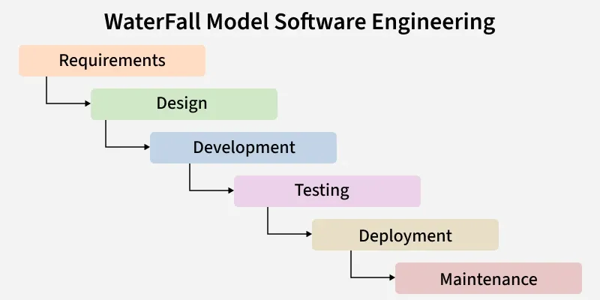
Waterfall Model
In a company, the Waterfall model is used when the project requirements are very clear and fixed from the beginning.
How a Company Uses Waterfall
- Client Meeting
The company meets the client and collects complete requirements.
- Documentation Phase
Business analysts prepare detailed documents like SRS.
Client approval is taken before moving ahead.
- Design Team Work
Architects and designers create system and database designs.
- Development Team
Developers write the code exactly according to the design.
- Testing Team
QA team tests the full software after development is complete.
- Delivery & Maintenance
The product is delivered, and support team handles issues later.

Example
A company developing banking software or government systems where rules do not change often.

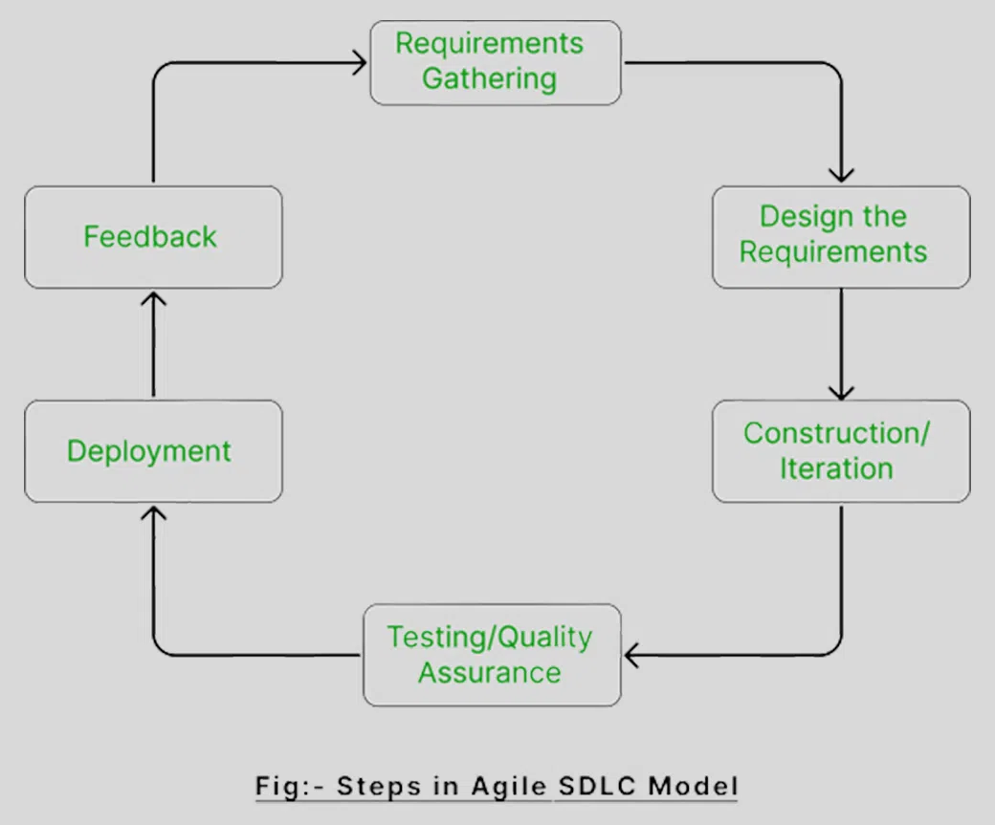
Agile Model
Companies use the Agile model when requirements are not fully clear and may change over time.
How a Company Uses Agile
- Product Owner
Represents the client and decides priorities.
- Sprint Planning
The team selects a small set of features to work on in a 2–3 week sprint.
- Development + Testing Together
Developers and testers work side by side.
- Daily Stand-up Meetings
Short meetings to discuss progress and issues.
- Sprint Review
A working version is shown to the client for feedback.
- Continuous Improvement
Feedback is used in the next sprint.

Example
A company building e-commerce websites, mobile apps, or startup products.

* (A-Star) Search Algorithm
What it is
A* is a path-finding algorithm used to find the shortest path from a start point to a goal.
It is commonly used in maps, games, robotics, and AI.
Main idea
A* chooses the best path using this formula:
f(n) = g(n) + h(n)
- g(n): actual cost from start to current node
- h(n): estimated cost from current node to goal (heuristic)
- f(n): total estimated cost
The node with the lowest f value is chosen next.
How it works (simple steps)
- Start from the initial node.
- Calculate f(n) for nearby nodes.
- Pick the node with the smallest f(n).
- Repeat until the goal is reached.
Example
Imagine finding the shortest path from your house to college:
- g(n): distance already travelled
- h(n): straight-line distance to college
- A* always moves in the direction that looks cheapest overall.
Why A* is good
- Finds the shortest path
- Faster than searching all paths
- Very efficient with a good heuristic

2. Sorting Algorithm (Overview)
What is sorting
Sorting means arranging data in a specific order, usually:
- Ascending (small to large)
- Descending (large to small)
Why sorting is important
- Makes searching faster
- Helps in data analysis
- Improves readability of data
Example:
Unsorted: 25, 11, 64, 12, 22
Sorted: 11, 12, 22, 25, 64

3. Bubble Sort
Idea
Bubble Sort compares adjacent elements and swaps them if they are in the wrong order.
Big values slowly move to the end like bubbles rising in water.
How it works
- Compare first two elements
- Swap if needed
- Move to the next pair
- Repeat multiple passes
Example
List:
25, 11, 64, 12, 22
Pass 1:
- 25 & 11 → swap → 11, 25, 64, 12, 22
- 64 moves towards the end
Final result:
11, 12, 22, 25, 64
Key points
- Very easy to understand
- Slow for large data
- Best for small lists

4. Selection Sort
Idea
Selection Sort repeatedly selects the smallest element from the unsorted part and places it at the correct position.
How it works
- Find the smallest element.
- Place it at the beginning.
- Repeat for the remaining list.
Example
List:
25, 11, 64, 12, 22
Step 1: smallest is 11 → place first
Step 2: next smallest is 12
Final:
11, 12, 22, 25, 64
Key points
- Simple logic
- Fewer swaps
- Not stable
- Slower for large lists

5. Insertion Sort
Idea
Insertion Sort works like sorting playing cards in your hand.
Each element is inserted into its correct position in the already sorted part.
How it works
- Start from second element
- Compare with previous elements
- Insert in the correct position
Example
List:
25, 11, 64, 12, 22
Steps:
- 11 inserted before 25
- 12 inserted between 11 and 25
Final:
11, 12, 22, 25, 64
Key points
- Very good for small or nearly sorted lists
- Stable sorting
- Simple and practical

6. Merge Sort
Idea
Merge Sort uses divide and conquer.
- Divide the list into smaller parts
- Sort them
- Merge them back in order
How it works
- Divide list into halves
- Keep dividing until single elements
- Merge them in sorted order
Example
List:
25, 11, 64, 12, 22
Divide:
[25, 11] [64, 12, 22]
Sort and merge:
[11, 25] [12, 22, 64]
Final merge:
11, 12, 22, 25, 64
Key points
- Very fast for large data
- Always efficient
- Uses extra memory
- Stable sorting

1. Reinforcement Learning (RL)
Reinforcement Learning is a type of machine learning where an agent learns by interacting with an environment.
The agent does not get the correct answer directly. Instead, it learns by trial and error using rewards.
Learning cycle:
- State (Input)
- Action (Response)
- Reward (Feedback)
- Learning
- Improved action next time
Example:
Input: APPLE
Agent response: Mongo
Feedback: Wrong
Correct answer: APPLE
Next time, the agent gives APPLE as output.

2. Q-Learning (Value-Based Learning)
Q-Learning is a value-based reinforcement learning algorithm.
The agent learns Q-values, which tell how good an action is in a given state. 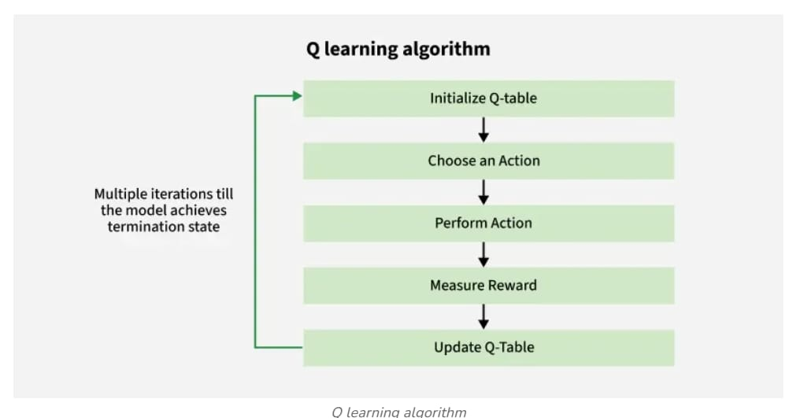
Q-value (Q(s,a))
It means the expected future reward when action a is taken in state s.
Example:
Q(APPLE, say “APPLE”) → high value
Q(APPLE, say “Mongo”) → low value
So the agent learns to choose the better action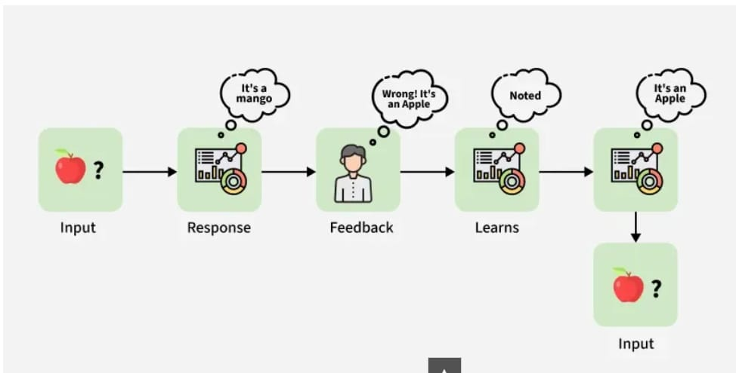

3. Q-Values (Action Values)
- Q-values store the quality of actions.
- Higher Q-value means better action.
- The agent updates Q-values after every action.
The agent always tries to increase its total reward.

4. Temporal Difference (TD) Learning
Temporal Difference learning means learning from difference between old and new values.
- Learning happens after every step
- No need to wait until the end
- Very fast and efficient
Example:
If an answer is wrong, the Q-value is reduced immediately.

5. Q-Learning Update Rule (TD Update)
Formula:
Q(s,a) ← Q(s,a) + α [ R + γ Q(s′,a′) − Q(s,a) ]
Meaning in simple words:
- α (alpha): learning speed
- R: reward or punishment
- γ (gamma): importance of future reward
- Q(s′,a′): expected future value
The agent slowly improves its knowledge.

6. Bellman Equation
Bellman equation helps calculate the best possible Q-value.
Formula:
Q(s,a) = R(s,a) + γ max Q(s′,a)
Simple meaning:
Current value = immediate reward + best future reward
The agent always thinks ahead.

7. Greedy Policy
A greedy policy means:
- Always choose the action with highest Q-value
- Focus only on best known option
Example:
If saying “APPLE” gives highest reward, the agent always chooses it.

8. Exploration and Exploitation
Exploitation:
- Use the best learned action
- Safe but limited learning
Exploration:
- Try new actions
- Helps discover better options
A good RL agent balances both.

9. Deep Q-Networks (DQN)
Deep Q-Networks combine Q-Learning and deep neural networks.
- Neural networks predict Q-values
- Used when state space is very large
- Example: video games, robotics
DQN removes the need for large Q-tables.

10. Policy Gradient Methods
Policy Gradient methods:
- Learn the policy directly
- Do not use Q-values
- Best for continuous or complex actions
Example:
Robot learning how much force to apply while walking.

Below is a clean, exam-ready summary for notes covering all the topics discussed in this chat.
Language is easy, explanation is clear, and examples are included so you can revise quickly before exams.

SEARCH ALGORITHMS – SUMMARY NOTES
(BFS, DFS, Best-First Search, Beam Search)

1. What is a Search Algorithm?
A search algorithm is used to find a path or solution from a start node to a goal node in a graph or tree.
In AI and Computer Science, search algorithms help in:
- Path finding
- Problem solving
- Decision making
Example:
Finding the shortest path in Google Maps.

2. Breadth First Search (BFS)
Meaning
BFS explores nodes level by level.
It visits all neighbors first before going deeper.
Working
- Start from the root node
- Visit all immediate neighbors
- Then visit neighbors of those neighbors
- Uses Queue (FIFO)
Example Graph
A
/ \
B C
/ \ \
D E F
BFS Traversal
A → B → C → D → E → F
Key Points
- Complete: Yes
- Optimal: Yes (shortest path)
- Memory: High
Real-World Example
- Shortest path in maps
- Social media friend suggestions
BFS Program in Python
from collections import deque

def bfs(graph, start):
visited = set()
queue = deque()

visited.add(start)
queue.append(start)

while queue:
node = queue.popleft()
print(node, end=" ")

for neighbor in graph[node]:
if neighbor not in visited:
visited.add(neighbor)
queue.append(neighbor)

# Graph representation
graph = {
'A': ['B', 'C'],
'B': ['D', 'E'],
'C': ['F'],
'D': [],
'E': [],
'F': []
}

print("BFS Traversal:")
bfs(graph, 'A')

Output
BFS Traversal:
A B C D E F

3. Depth First Search (DFS)
Meaning
DFS goes deep first along one path and backtracks when no path is left.
Working
- Start from root
- Go to one child
- Keep going deeper
- When stuck, go back
- Uses Stack or Recursion
Example Graph
A
/ \
B C
/ \
D E
DFS Traversal
A → B → D → E → C
Key Points
- Complete: No
- Optimal: No
- Memory: Low
Real-World Example
- Maze solving
- File system search

4. DFS Python Example
def dfs(graph, node, visited):
if node not in visited:
print(node, end=" ")
visited.add(node)
for neighbor in graph[node]:
dfs(graph, neighbor, visited)

graph = {
'A': ['B', 'C'],
'B': ['D', 'E'],
'C': ['F'],
'D': [],
'E': [],
'F': []
}

visited = set()
dfs(graph, 'A', visited)
Output
A B D E C F

5. Best-First Search
Meaning
Best-First Search chooses the most promising node based on a heuristic value.
Heuristic Function
f(n) = h(n)
Where h(n) = estimated distance from goal.
Working
- Node with lowest heuristic value is expanded first
- Uses Priority Queue
Key Points
- Faster than BFS
- Depends on heuristic
- Not always optimal
Real-World Example
- Game AI
- Robot navigation

6. Beam Search
Meaning
Beam Search is a limited version of Best-First Search.
It keeps only k best nodes at each level.
Beam Width (k)
- k = number of nodes kept
- Others are removed
Working
- Expand nodes level-wise
- Keep only top k nodes
- Continue search
Key Points
- Very fast
- Low memory
- May miss correct solution
Real-World Example
- Speech recognition
- Machine translation
- NLP models

1. Neural Network (Quick context)
A neural network is a model inspired by the human brain.
It learns from data by adjusting weights to reduce errors.
It is mainly used in:
- Image recognition
- Speech recognition
- Spam detection
- Recommendation systems

2. Layers in a Neural Network
A neural network trained using back propagation has three main layers.
(a) Input Layer
- Receives input data
- No calculations are done here
Example: pixels of an image, marks of a student
(b) Hidden Layer(s)
- One or more layers
- Performs actual processing
- Extracts patterns from data
(c) Output Layer
- Gives final prediction
Example: Yes/No, 0–9 digit, Spam/Not Spam
Minimum layers = 3
Hidden layers = one or more

3. Passes in Neural Network
Each training cycle has two passes.
(a) Forward Pass
- Data flows from input → hidden → output
- Prediction is calculated
- No weight update happens
(b) Backward Pass
- Error flows backward
- Weights are updated using gradients
Total passes = 2

4. Forward Propagation
Meaning
Forward propagation is the process of passing input data through the network to produce an output.
Steps
- Input is given
- Weighted sum is calculated
[
z = wx + b
]
- Activation function is applied
- Output is generated
Example
Spam detection:
- Input: email words
- Output: Spam (0) or Not Spam (1)
Forward propagation only predicts, it does not learn.

5. Back Propagation
Meaning
Back propagation is a learning algorithm that reduces error by updating weights.
In simple words:
Error goes backward and corrects the network.
Steps
- Perform forward propagation
- Calculate error
- Send error backward
- Update weights using gradients
Why it is important
- Helps network learn
- Improves accuracy
- Foundation of deep learning
Real-world example
Handwritten digit recognition
- Model predicts wrong digit
- Error is calculated
- Weights are corrected
- Prediction improves next time

6. Efficient Weight Update
Meaning
Efficient weight update means changing weights in a way that:
- Learning is fast
- Error reduces smoothly
- Less computation is used
Common methods
- Gradient Descent
- Stochastic Gradient Descent (SGD)
- Adam Optimizer
Formula
[
w_{new} = w_{old} - eta frac{partial Error}{partial w}
]
Where ( eta ) is learning rate.

7. Sigmoid Function
Meaning
The sigmoid function is an activation function that converts any value into 0 to 1 range.
Formula
[
sigma(x) = frac{1}{1 + e^{-x}}
]
Why sigmoid is used
- Output looks like probability
- Useful for binary classification
Example
- Output = 0.9 → Yes
- Output = 0.1 → No
Derivative (used in back propagation)
[
sigma'(x) = sigma(x)(1 - sigma(x))
]

8. Relation between Forward and Back Propagation
Forward Propagation | Back Propagation
Predicts output | Corrects error
No weight update | Updates weights
Input → Output | Output → Input
Both work together to train a neural network.

9. Simple Real-World Example (Complete flow)
Example: Email Spam Filter
- Forward propagation
  - Email features are input
  - Network predicts spam or not
- Error calculation
  - Prediction is compared with actual result
- Back propagation
  - Error flows backward
  - Weights are adjusted
- Efficient update
  - Learning rate controls speed
  - Sigmoid helps in smooth learning
Over time, the system becomes accurate.

